Site Inspector / Sample project
Photo inspection report
Sample office entrance
DEMO-2026-0927
Client: Fictional office
Auditor: Demo inspector
Report selection: All
Assigned to: All
Due on or before: All
Findings: 1 / 1
Unresolved 0 · In progress 0 · Resolved 1
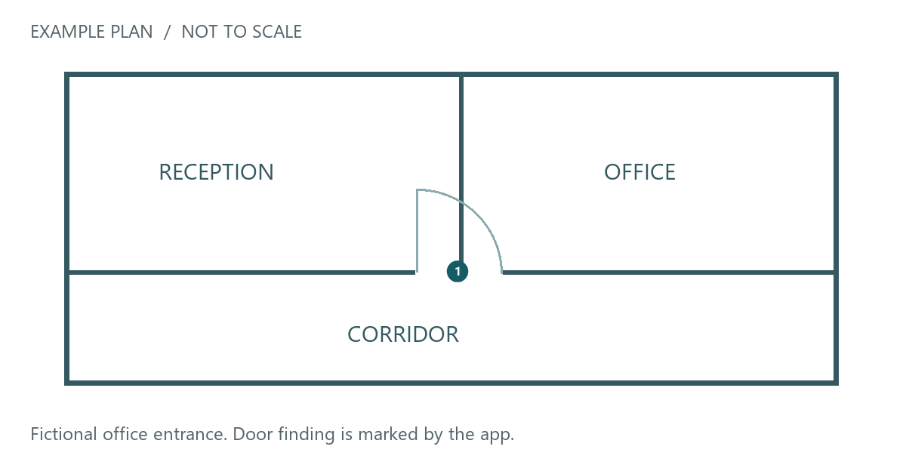
Finding 1 · Door alignment at entrance
Ground floor / entrance door · Resolved
Assigned to: Sample maintenance team
Due date: 2026-09-27
Fictional demo with AI-generated photos. Before: uneven latch-side gap. After: a narrower, uniform seam.
Finding 1 · Door alignment at entrance
Before  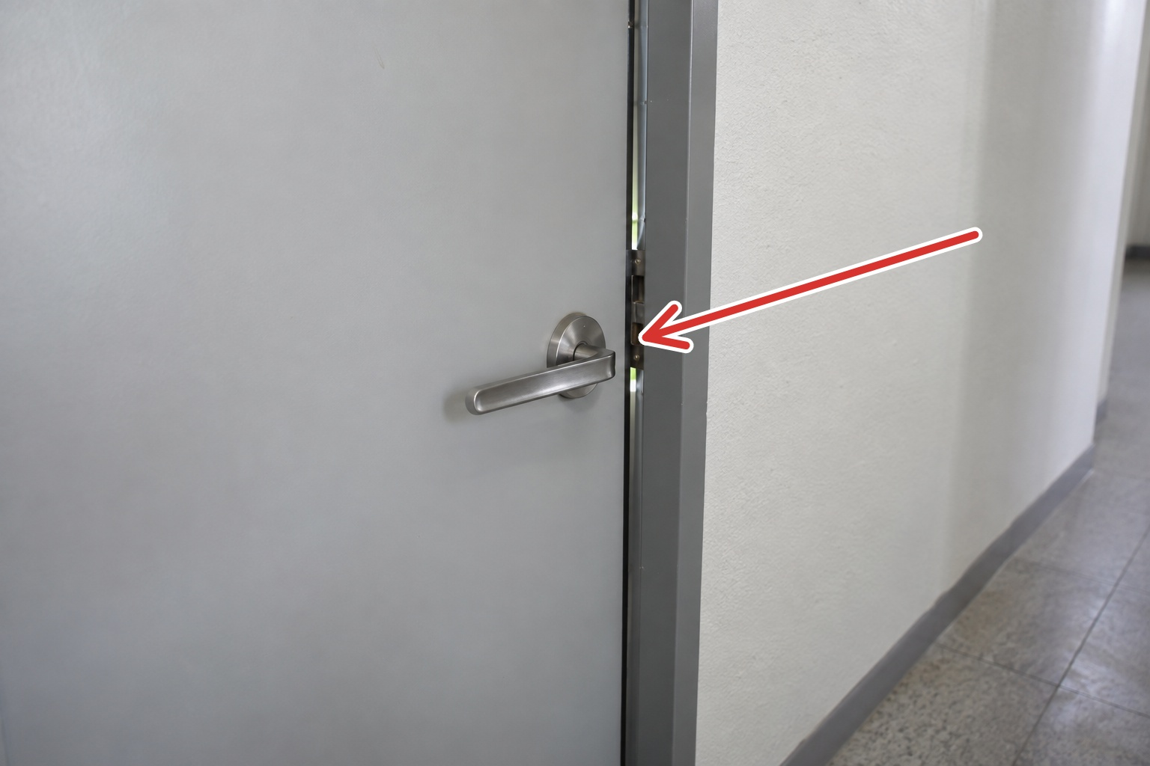 | After  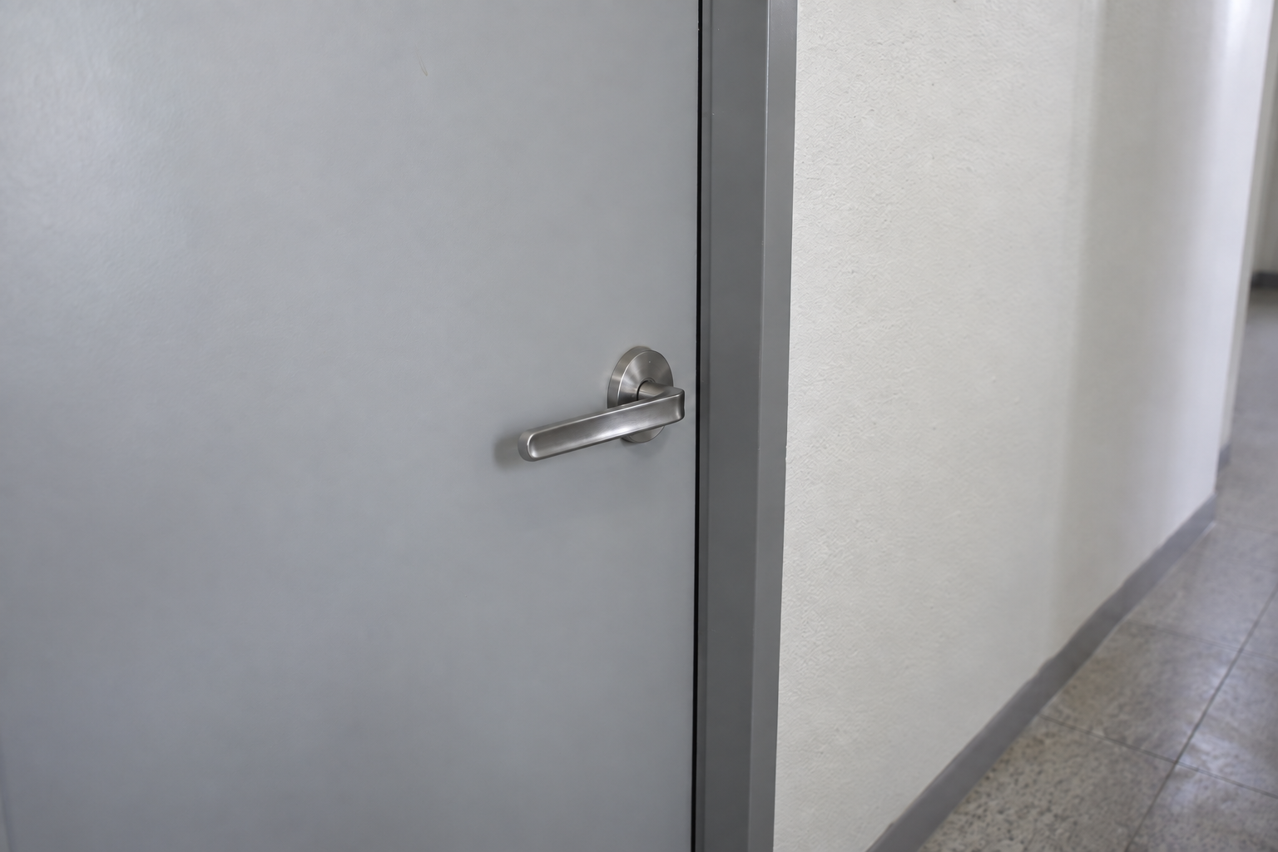

Fictional demonstration. AI-generated example photos. Not an actual inspection.

