Site Inspector / Edited delivery example
Photo inspection report
Sample office entrance
DEMO-2026-0927
Client: Fictional office
Auditor: Demo inspector
Report selection: All
Assigned to: All
Due on or before: All
Findings: 1 / 1
Unresolved 0 · In progress 0 · Resolved 1
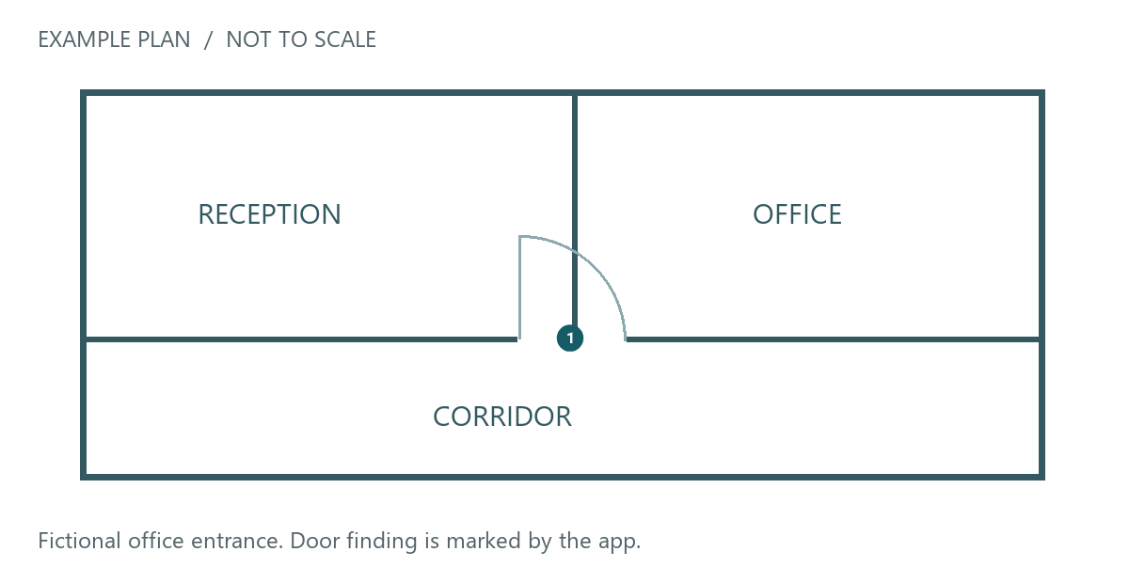
Finding 1 · Door alignment at entrance
Ground floor / entrance door · Resolved
Assigned to: Sample maintenance team
Due date: 2026-09-27
Fictional demo with AI-generated photos. Before: uneven latch-side gap. After: a narrower, uniform seam.
Finding 1 · Door alignment at entrance
Before  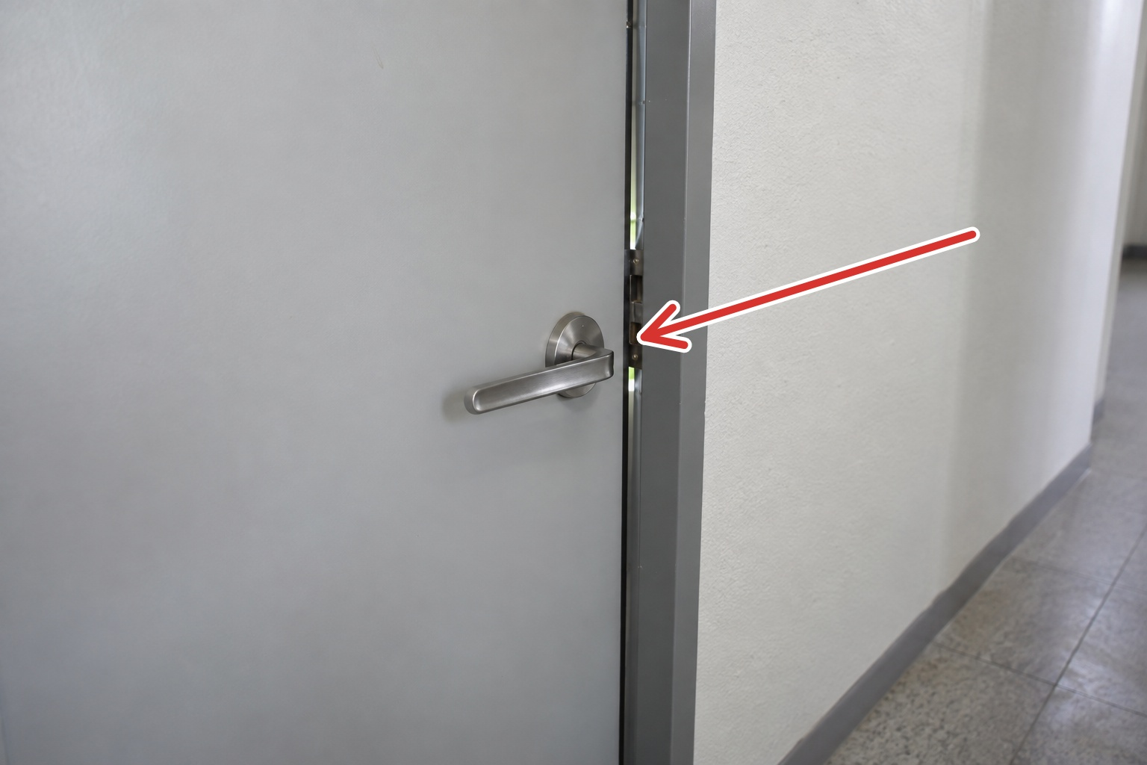 | After  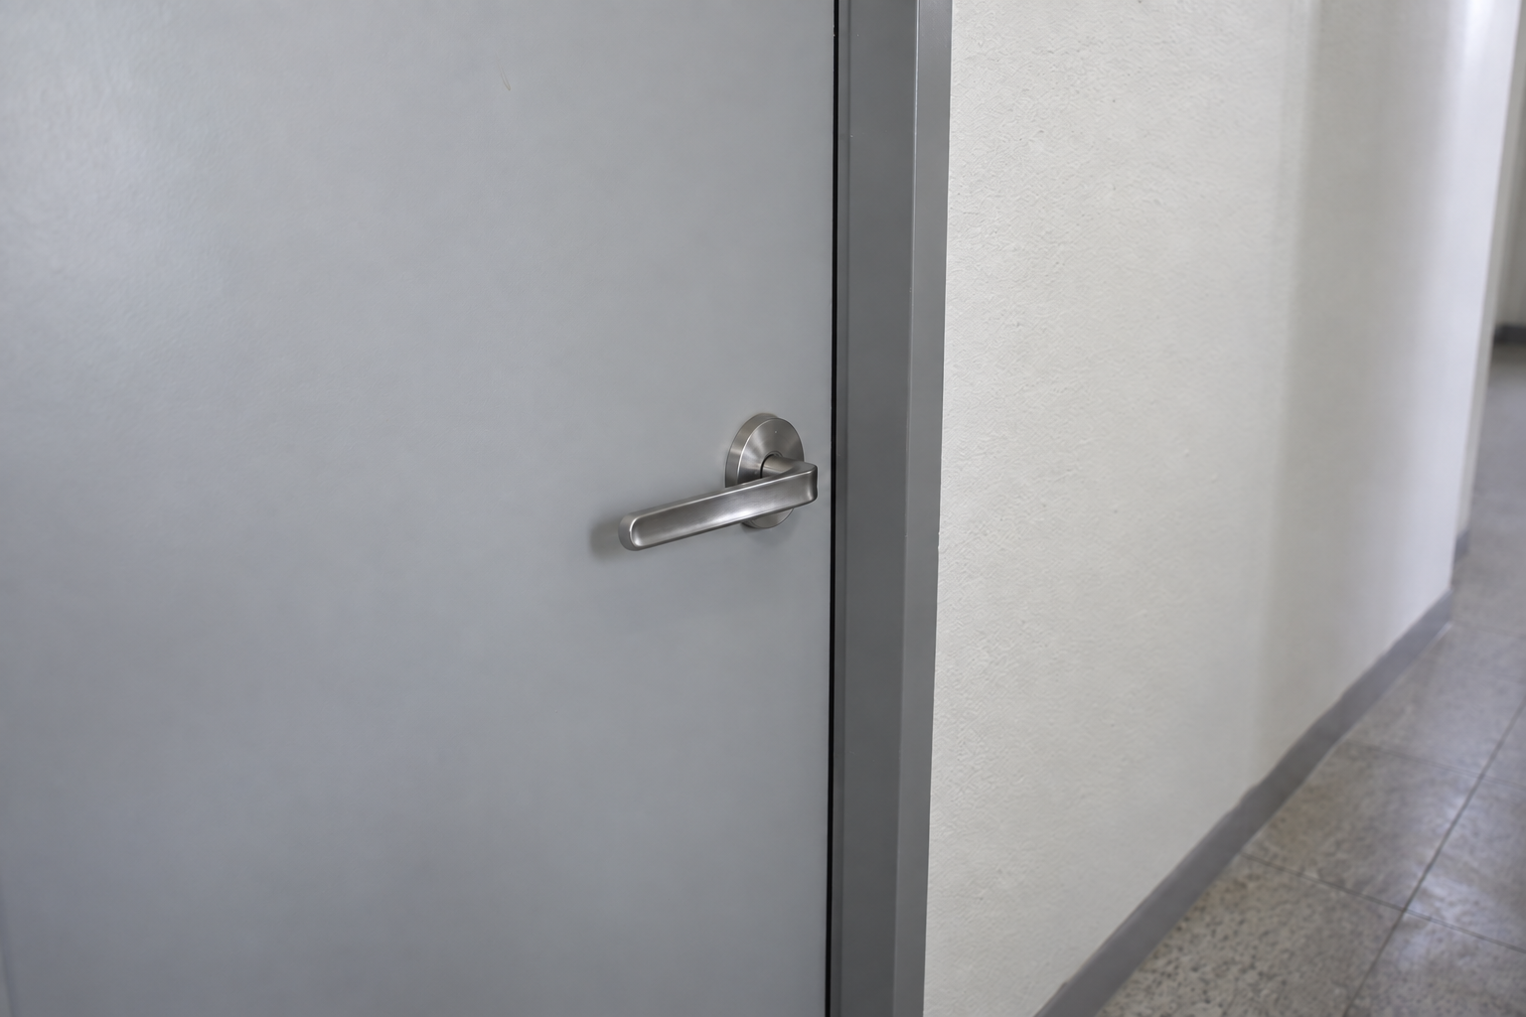

Fictional demonstration. AI-generated example photos. Not an actual inspection.
Delivery note
Prepared for the fictional office facilities team. Please review the paired photos alongside the finding and the numbered plan location.
Next action
On the next visit, check that the door closes and latches correctly. Record any remaining concern as a new finding. This is a sample follow-up instruction, not a completed test.
Edited outside Site Inspector
These delivery notes were added to the exported DOCX outside the app. The photos, numbered plan pin and original finding came from the app export. Fictional example with AI-generated photos.

